Teacher Notes for “How Meiosis and Fertilization Produce Genetic Diversity
(In Contrast to Asexual Reproduction)”

In this analysis and discussion activity, students learn how meiosis produces genetically diverse gametes by analyzing the effects of crossing over and independent assortment. Students figure out why no two siblings (except identical twins) have exactly the same alleles. A final section contrasts sexual reproduction with asexual reproduction.

We recommend that, before your students begin this activity, you have them complete "Understanding How Genes are Inherited via Meiosis and Fertilization" (https://serendipstudio.org/exchange/bioactivities/meiosisRR)

Learning Goals
In accord with the Next Generation Science Standards:
      - Students will gain understanding of the Disciplinary Core Idea:
- LS3.B: Variation of Traits – "In sexual reproduction, chromosomes can sometimes swap sections during the process of meiosis (cell division), thereby creating new genetic combinations and thus more genetic variation."
- This activity helps to prepare students for the Performance Expectation:
- HS-LS3-2, "Make and defend a claim based on evidence that inheritable genetic variations may result from: (1) new genetic combinations through meiosis…"
- Students will engage in the Scientific Practices:
- “Developing and Using Models – Develop, revise, and/or use a model (including mathematical and computational) to generate data to support explanations, predict phenomena, analyze systems, and/or solve problems."
- “Constructing Explanations – Apply scientific ideas, principles and/or evidence to provide an explanation of phenomena…".
- This activity provides the opportunity to discuss the Crosscutting Concepts
- "Systems and system models – … Models can be valuable in predicting a system’s behaviors…"
- “Cause and Effect – Cause and effect relationships may be used to predict phenomena in natural or designed systems.”
Additional Content Learning Goals
- Different gametes produced by the same person have different genetic makeup due to the separation of homologous chromosomes with different alleles into different gametes, crossing over, and independent assortment.
- The genetic diversity of the sperm and eggs produced by each parent results in genetic diversity of the different offspring produced by the same mother and father.
This activity will help students overcome the following common misconceptions. Sexual repro-duction is not recognized as a source of variation. Students do not understand the role of chance in producing new heritable characteristics by forming new combinations of existing genes.

Instructional Suggestions and Background Biology
To maximize student learning and participation, we recommend that you have students work in pairs to answer each group of related questions. Student learning is increased when students discuss scientific concepts to develop answers to challenging questions. After pairs of students have worked together to answer a group of related questions, we recommend that you have a class discussion to probe student thinking and help students develop a sound understanding of the concepts and information covered.

If you would like to have a key with the answers to the questions in the Student Handout, please send a message to iwaldron@upenn.edu. The following paragraphs provide additional background information and instructional suggestions. Much of the following information is more sophisticated than would be appropriate for high school students, but this information can be useful for your own understanding and for responses to questions from your students.

In our experience, our emphasis on understanding how specific genes are transmitted by meiosis and fertilization contributes to student interest and enhances understanding. Human chromosome 11 has the genes that can result in albinism and/or sickle cell anemia, as well as more than 1000 other genes. Human chromosome 12 has more than 1000 genes, including a gene that can result in alcohol intolerance. Humans have a total of 23 pairs of homologous chromosomes, with a total of roughly 20,000 genes.

Albinism
This figure shows that a melanocyte produces melanin which is transferred to the keratinocytes that make up the bulk of our skin. Melanin protects the DNA of the keratinocytes from UV damage and helps to prevent the breakdown of folic acid. On the other hand, too much melanin can interfere with the production of vitamin D, which is needed for calcium absorption. | 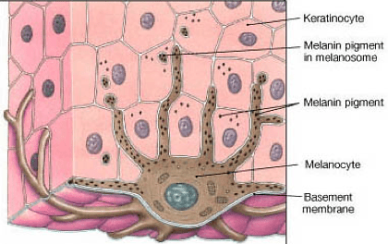  (https://lmskincentre.com/en/skin-blog/medical-cosmetic-treatment/risk-and-control-melanocyte/)

The enzyme, tyrosinase, catalyzes the rate-limiting step in melanin production. Useful sources of additional information about tyrosinase and different types of melanin are https://en.wikipedia.org/wiki/Tyrosinase and https://www.ncbi.nlm.nih.gov/books/NBK459156/.
An allele that codes for a non-functional tyrosinase causes albinism. In this type of albinism, the non-functional enzyme for producing melanin not only results in albino skin and hair color, but also affects the appearance and function of the eyes. Further information about albinism is available at https://medlineplus.gov/ency/article/001479.htm and https://omim.org/entry/203100. You may want to mention that other genes and the environment also affect skin color (see our hands-on activity, “Were the babies switched? – The Genetics of Blood Types and Skin Color”; https://serendipstudio.org/sci_edu/waldron/#blood).

Sickle cell anemia
Sickle cell hemoglobin is less soluble in the watery cytosol of the red blood cells than normal hemoglobin, particularly when oxygen concentration is low. Consequently, sickle cell hemoglobin tends to form long stacks or rods of hemoglobin molecules. This results in the sickled or crescent shape of some red blood cells in a person who is homozygous for the sickle cell allele and consequently has sickle cell anemia. The sickled red blood cells tend to clog the tiny capillaries, blocking the circulation to different parts of the body. Also, the sickled red blood cells do not survive as long as normal red blood cells, which contributes to anemia. Resulting symptoms include pain, physical weakness, impaired mental functioning, and damage to organs such as the heart and kidneys.

Genotype (genes) | → | Protein | → | Phenotype (characteristics)
2 copies of the allele  that codes for  normal hemoglobin  (HH) | → | Normal hemoglobin dissolves in the cytosol of red blood cells.  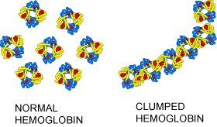 | → | Disk-shaped red blood cells can squeeze through the smallest blood vessels → normal health  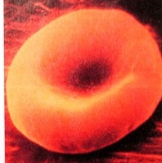
2 copies of the allele  that codes for  sickle cell hemoglobin (hh) | → | Sickle cell hemoglobin  can clump in long rods  in red blood cells. | → | When sickle cell hemoglobin clumps in long rods  → sickle-shaped red blood cells  → clogged small blood vessels  + fragile red blood cells  → pain, damage to body organs  + anemia = sickle cell anemia  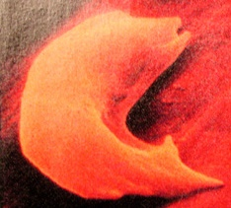

In a person who is heterozygous for the sickle cell and normal hemoglobin alleles, each red blood cell contains both sickle cell and normal hemoglobin. The amount of normal hemoglobin is sufficient to prevent the symptoms of sickle cell anemia in almost all cases. The sickle cell hemoglobin in each red blood cell decreases the severity of malaria in heterozygous individuals because the malaria parasite doesn't grow as well in red blood cells containing sickle cell hemoglobin. Decreased severity of malaria is an advantage that resulted in natural selection for the sickle cell hemoglobin allele in regions where malaria was prevalent.

-A good summary of the medical aspects of sickle cell anemia, including symptoms, diagnosis and treatment is available at https://www.mayoclinic.org/diseases-conditions/sickle-cell-anemia/symptoms-causes/syc-20355876.
-A video, "Sickle cell anemia" is available at
https://www.biointeractive.org/classroom-resources/sickle-cell-disease.
-Recent progress in gene therapy for sickle cell anemia is described in
https://www.fda.gov/news-events/press-announcements/fda-approves-first-gene-therapies-treat-patients-sickle-cell-disease.

Alcohol Intolerance
The enzyme, acetaldehyde dehydrogenase, plays an important role in alcohol metabolism.

alcohol dehydrogenase acetaldehyde dehydrogenase
alcohol acetaldehyde acetic acid

Non-functional acetaldehyde dehydrogenase results in the accumulation of high levels of acetaldehyde after drinking alcohol. The accumulation of acetaldehyde results in unpleasant symptoms including increased heart rate and stroke volume and associated heart palpitations, increased blood flow to the skin and flushing, and a general "terrible feeling overall". This condition is called alcohol sensitivity or alcohol intolerance.

Heterozygous individuals have alcohol intolerance, due to substantial accumulation of acetaldehyde. One major reason why the allele for the non-functional enzyme is dominant is that the functional enzyme is a tetramer and even one abnormal protein in the tetramer may inactivate the enzyme. Although heterozygous individuals are alcohol intolerant, alcohol intolerance is more severe in homozygous individuals who experience very unpleasant symptoms whenever they drink alcohol and consequently almost never develop alcoholism.

The drug Antabuse (disulfiram), which is given to treat alcohol abuse, works by blocking the enzyme acetaldehyde dehydrogenase. This results in increased concentrations of acetaldehyde and the resultant highly unpleasant symptoms if a person drinks.

The allele that results in alcohol intolerance is relatively common in people of East Asian descent, but extremely rare in people of European descent.

Useful general introductions to this topic are available at https://www.mayoclinic.org/diseases-conditions/alcohol-intolerance/symptoms-causes/syc-20369211 and https://en.wikipedia.org/wiki/Alcohol_flush_reaction, and a more technical description is available at https://omim.org/entry/100650?search=100650&highlight=100650.

Questions 1-9
It may be helpful to have a name for the process that leads to the diverse genetic combinations in the zygote/offspring that is illustrated in answer to question 2. Random fertilization is the process in which a particular sperm cell reaches the egg first and fertilizes a particular egg.

To answer question 5, students should focus on independent assortment and assume that crossing over does not occur. Student answers to question 5 should show that independent assortment of two pairs of homologous chromosomes results in 2² = 4 different combinations of alleles. Similarly, independent assortment of the 23 human chromosomes results in 2²³ = 8.4 million different combinations of alleles.

After question 5, we recommend that you review how meiosis produces genetic diversity by showing your students one of these videos. The ~2-minute video, “Meiosis” (https://www.youtube.com/watch?v=D1_-mQS_FZ0) is the briefest. More sophisticated students may appreciate the ~13-minute video “Meiosis and Genetic Diversity | AP biology 5.2” (https://www.youtube.com/watch?v=bEzFYeQFw7E). If you want to introduce the phases of meiosis I and meiosis II, you can use the video described in the preceding sentence or the 7-minute video, “Meiosis” (https://www.youtube.com/watch?v=VzDMG7ke69g).

Student answers to question 6a should focus on random fertilization, while answers to question 6b should focus on crossing over.

Questions 8-9 should reinforce student understanding of the contributions of crossing over and independent assortment to genetic diversity among siblings. During meiosis, independent assortment of the 23 pairs of homologous chromosomes can produce more than 8 million different combinations of chromosomes in the different eggs or sperm produced by one person. If each different type of egg from one mother could be fertilized by each different type of sperm from one father, this would produce zygotes with more than 64 trillion different combinations of chromosomes! Crossing over results in an even greater amount of genetic diversity. Thus, it is easy to understand why no two people are genetically identical (except for identical twins who both developed from the same zygote).

Question 9 can be used for formative assessment. If this question is too challenging for your students, you can provide scaffolding for your students as follows.
- If your students have trouble learning vocabulary, you may want to precede question 9 with a question that asks for definitions of the terms listed (or perhaps a matching question in which you provide your preferred definitions for these terms).
- As an introduction to this question, you may want to provide a concept map or graphic organizer for your students to review or complete (e.g., https://www.easynotecards.com/uploads/111/63/_25c4e1b0_158bcac4ea7__8000_00000674.PNG).
- Students may benefit from a preliminary small group discussion of the points they want to include in their answers, using the vocabulary list to suggest relevant concepts. However, each student should prepare a written answer in his or her own words.
- You may want to provide an initial sentence stem to help your students begin their answers.

Comparing Sexual Reproduction with Asexual Reproduction
In answer to question 10, sophisticated students may point out that there might be some genetic differences due to somatic mutations. However, the main point is that mitosis produces genetically identical (or nearly identical) daughter cells, in contrast to the abundant genetic diversity of offspring produced by sexual reproduction.

Aspens can reproduce both sexually and asexually (see figure below). Good discussions of the giant aspen clone are provided in https://en.wikipedia.org/wiki/Pando_(tree) and https://www.nature.com/scitable/knowledge/library/case-study-the-glorious-golden-and-gigantic-13261308/.

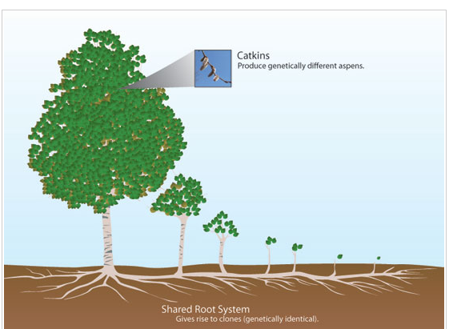
(https://www.nature.com/scitable/knowledge/library/case-study-the-glorious-golden-and-gigantic-13261308/)

If your students are familiar with natural selection, you may want to follow up question 12b, with a discussion of how the genetic diversity produced by sexual reproduction provides much of the raw material for natural selection.

An interactive activity for review and to learn more about asexual vs. sexual reproduction is available at https://learn.genetics.utah.edu/content/basics/reproduction/.

Follow-Up Activities
Comparing Mitosis and Meiosis (https://serendipstudio.org/exchange/bioactivities/MitosisMeiosisC)
In this minds-on analysis and discussion activity, students review mitosis and meiosis as they compare and contrast meiosis and mitosis. The Teacher Notes for this activity include an optional mitosis and meiosis card sort.

How Mistakes in Meiosis Can Result in Down Syndrome or Death of an Embryo (https://serendipstudio.org/exchange/bioactivities/mmfmistakes)
In this minds-on analysis and discussion activity, students learn how a mistake in meiosis can result in Down syndrome. Students also analyze karyotypes to learn how other mistakes in meiosis can result in the death of an embryo. Finally, students consider how a health problem can be genetic, but not inherited.

We recommend that the mitosis and meiosis activities be followed by one of our introductory genetics activities:
- Genetics (https://serendipstudio.org/sci_edu/waldron/#genetics) or
- Introduction to Genetics – Similarities and Differences Between Family Members (https://serendipstudio.org/exchange/bioactivities/geneticsFR).
Either of these activities will further demonstrate how meiosis and fertilization provide the basis for understanding inheritance. These activities are part of an integrated sequence of learning activities for teaching genetics, presented in "Genetics – Major Concepts and Learning Activities" (available at https://serendipstudio.org/exchange/bioactivities/GeneticsConcepts).

A Mitosis, Meiosis and Fertilization Vocabulary Game to reinforce learning of relevant vocabulary is available at https://serendipstudio.org/exchange/bioactivities/mmfvocabgame.

Sources for Figures in the Student Handout
- Figure on the top of page 2 – modified from http://biologyequalslife.weebly.com/uploads/3/7/8/5/37850945/884166_orig.gif
- First Figure on page 4 from https://www.sciencefacts.net/budding.html
- Second figure on page 4 from https://www.nature.com/scitable/knowledge/library/case-study-the-glorious-golden-and-gigantic-13261308/
The other figures were prepared by the first author.

By Drs. Ingrid Waldron, Jennifer Doherty, Scott Poethig and Lori Spindler, Department of Biology, University of Pennsylvania, 2025. These Teacher Notes and the Student Handout are available at https://serendipstudio.org/exchange/bioactivities/gendiversity.
Quotations from https://www.nextgenscience.org/ and https://www.nextgenscience.org/sites/default/files/HS%20LS%20topics%20combined%206.13.13.pdf.
These misconceptions are paraphrased from a useful discussion of key concepts, common misconceptions, and learning activities for meiosis and variation in Chapter 3 of Hard to Teach Biology Concepts by Susan Koba with Ann Tweed, 2009, NSTA Press.

